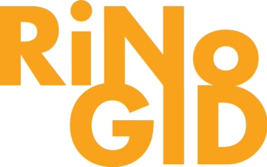

GID BOARD MEETING
MEETING AGENDA
Wednesday, May 27, 10:30 AM - 12:00 PM
Fabrica RiNo

- Call to Order (10:30a-10:35am)
- Voting Matters (10:30a-10:45am)
  - RiNo Arts District Grant Request (10:35a-10:50a)
  - April Financials*(10:50a-11:00a)
  - Capital Improvement Planning with Summit Street Group (11:00a-11:55a)
- High-level update on landscaping, safety, GID ordinance (11:55a-12:00p)
- Adjourn (12:00pm)

*Indicates that additional information can be found in this meeting packet.

